***TRAFFIC MONITORING SYSTEM***

**IOT PHASE:3 SUBMISSION DOCUMENT**

**ABSTRACT:**

* 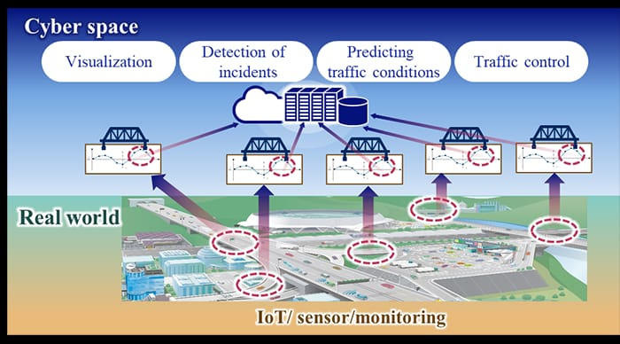The traffic monitoring system employing traffic flow sensors represents an innovative approach to urban management. This system relies on strategically placed sensors to collect real-time data on vehicular movement, enabling precise analysis of traffic patterns.

**OBJECTIVE:**

* Real-time data on vehicle movement.
* Congestion.
* Flow to optimize traffic flow.
* Improve safety.
* Infrastructure development.

**COMPONENTS OF TRAFFIC MONITORING SYSTEM:**

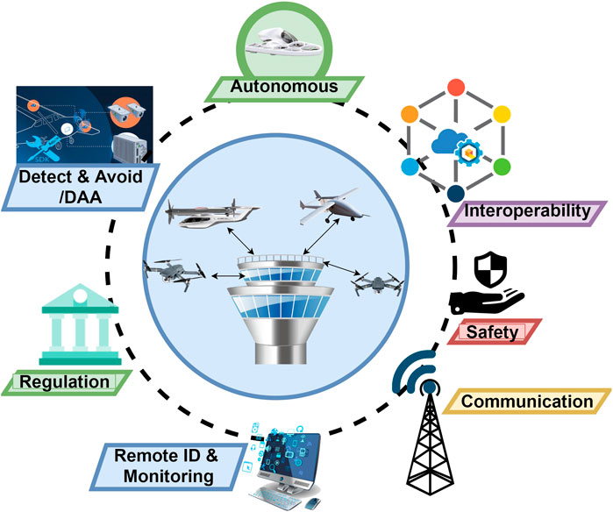

**\*Sensors:\***

- Cameras for video surveillance.

- Inductive loop detectors embedded in road surfaces.

- Radar or lidar sensors for speed detection.

**\*Communication Infrastructure:\***

- Network connectivity for data transmission.

- Wireless or wired communication systems.

**\*Data Processing Units:\***

- Computers or servers to process and analyze collected data.

- Algorithms for traffic pattern recognition and analysis.

**\*Central Control System:\***

- Centralized software for managing and coordinating traffic data.

- User interface for monitoring and control.

**\*Database:\***

- Storage for historical and real-time traffic data.

- Enables trend analysis and reporting.

**\*Traffic Management Software:\***

- Applications for controlling traffic signals and managing congestion.

- Integration with other intelligent transportation systems.

**\*Power Supply:\***

- Reliable power sources for continuous operation.

**\*User Interface:\***

- Display systems for operators to visualize data.

- Control interfaces for manual intervention if needed.

**\*Algorithms and Analytics:\***

- Intelligent algorithms for traffic prediction, optimization, and anomaly detection.

**\*Integration with Other Systems:\***

- Coordination with emergency services, public transportation, or smart city infrastructure.

**\*Maintenance and Diagnostics:\***

- Systems for monitoring the health of components and predicting maintenance needs.

**SENSORS USED:**

**\*Inductive Loop Sensors:\***

**DEFINITION:**

* Buried in the road, these detect the presence of vehicles by changes in inductance.



* An inductive loop sensor is a type of sensor commonly used in traffic management and vehicle detection systems.
* It typically consists of a wire loop embedded in the pavement, forming a coil.
* When a conductive object such as a vehicle passes over the loop, it disrupts the magnetic field, allowing the sensor to detect the presence or passage of the vehicle.
* Inductive loop sensors are widely used in traffic management and control systems. Some of their key applications include:
* Vehicle detection:

Inductive loop sensors can detect the presence and movement of vehicles, allowing for the implementation of traffic light control systems and automatic toll collection systems.

* Traffic monitoring:

These sensors can provide real-time data on traffic flow, enabling authorities to monitor and manage traffic conditions, optimize signal timings, and improve overall traffic management strategies.

* Vehicle counting:

Inductive loop sensors are often used to count the number of vehicles passing through specific points, aiding in the analysis of traffic patterns and trends for planning and decision-making purposes.

* Incident detection:

By sensing disruptions in the normal traffic flow, inductive loop sensors can help in detecting accidents or other incidents, allowing for a quicker response from emergency services and traffic management authorities.

**PIN CONFIGURATION:**

*Loop Input/Output:*

- Pin 1: Loop Output (Connects to the traffic signal controller or processing unit)

- Pin 2: Ground (GND)

- Pin 3: Loop Input (Connects to the loop coil)

**\*Video Cameras:\***

DEFINITION:

* Capture real-time footage for visual monitoring and analysis.

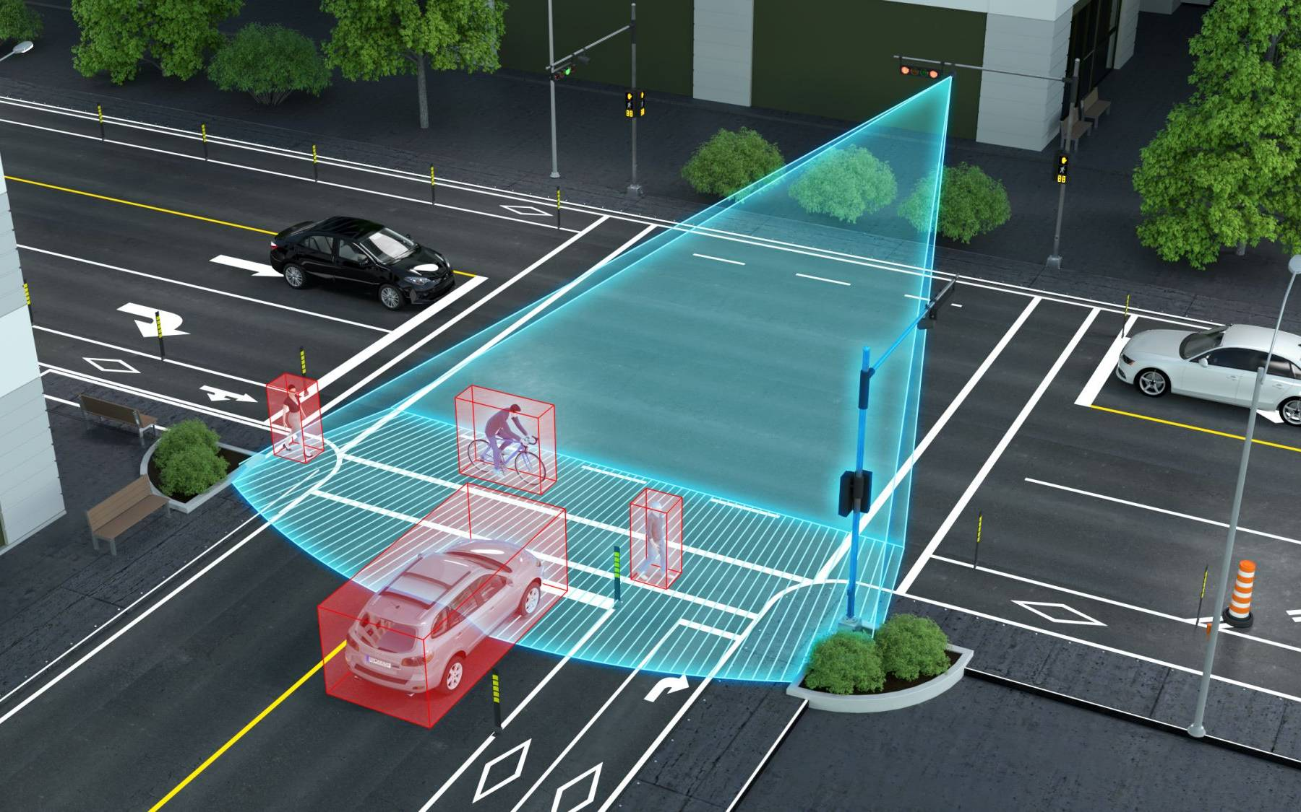

* A video camera traffic monitoring system typically uses a network of cameras to capture and monitor traffic patterns, violations, and incidents on roadways.
* These systems often employ advanced image processing techniques, including object recognition and tracking, to detect and analyze various parameters such as
* vehicle speed,
* traffic density
* compliance with traffic rules.

PIN CONFIGURATION:

1. *Power and Ground:*

- Pin 1: Power (Vcc)

- Pin 2: Ground (GND)

2. *Video Output:*

- Pin 3: Video Output (analog or digital signal)

3. *Audio (if applicable):*

- Pin 4: Audio Output (for cameras with built-in microphones)

4. *Data Communication (for IP Cameras):*

- Pin 5: Data+ (for data communication in IP cameras)

- Pin 6: Data- (for data communication in IP cameras)

5. *Control (if applicable):*

- Pin 7: Control signals (e.g., PTZ - Pan, Tilt, Zoom control)

**\*Radar Sensors:\***

DEFINITION:

* Use radio waves to detect the speed and presence of vehicles.

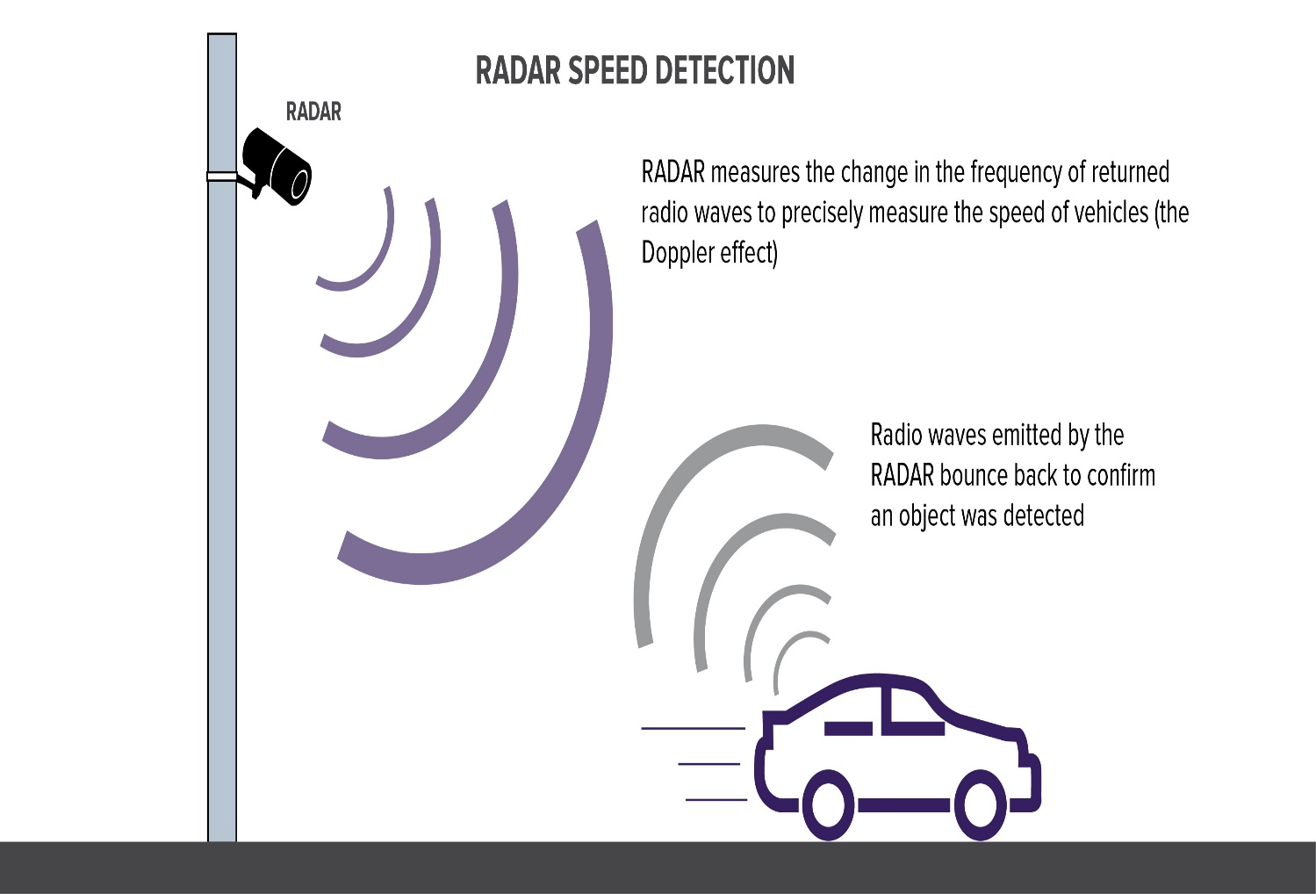

* A radar sensor traffic monitoring system typically employs radar technology to detect and monitor the flow of traffic on roads or highways.
* These systems use radar waves to measure the speed, volume, and movement of vehicles, providing valuable data for traffic management and control.

PIN CONFIGURATION:

1. *Power Supply:*

- Pin 1: Power (Vcc)

- Pin 2: Ground (GND)

2. *Signal Output:*

- Pin 3: Signal Output (providing information about detected objects, speed, or distance)

3. *Control/Input (optional):*

- Pin 4: Control/Input (for configuration or triggering specific functionalities)

4. *Communication (for networked or advanced radar systems):*

- Pin 5: Communication (TX/RX for data exchange in networked systems)

5. *Antenna Connections (for radar modules with separate antennas):*

- Pin 6: Antenna Connection 1

- Pin 7: Antenna Connection 2

**\*LiDAR (Light Detection and Ranging):\***

**DEFINITION:**

* Similar to radar but uses laser light to measure distances and create detailed maps.

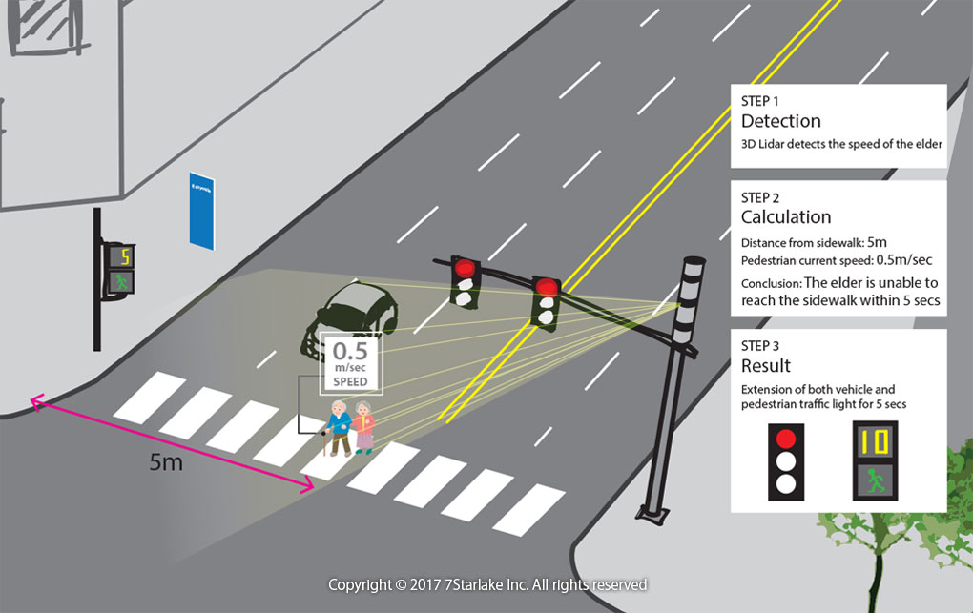

* A LiDAR (Light Detection and Ranging) traffic monitoring system utilizes laser-based technology to measure the distance to an object or surface.
* It can be employed for various applications, including traffic m It operates by sending out laser pulses and measuring the time it takes for the light to reflect off objects and return to the sensor.
* By analyzing the properties of the reflected light, such as intensity and wavelength, LiDAR systems can create precise three-dimensional representations of objects and environments.
* This technology is widely used in various fields, including geography, geology, seismology, archaeology, forestry, atmospheric physics, and autonomous vehicle **navigation.onitoring**, speed detection, and vehicle counting.

PIN CONFIGURATION:

1. *Power Supply:*

- Pin 1: Power (Vcc)

- Pin 2: Ground (GND)

2. *Data Interface:*

- Pin 3: Data Output (providing information about the LiDAR measurements)

3. *Communication (optional):*

- Pin 4: Communication (TX/RX for data exchange in networked systems)

4. *Control/Input (optional):*

- Pin 5: Control/Input (for configuration or triggering specific functionalities)

5. *Enable/Disable (optional):*

- Pin 6: Enable/Disable (for turning the LiDAR on or off)

6. *Serial Communication (for LiDARs with UART or other serial interfaces):*

- Pin 7: RX (Receive)

- Pin 8: TX (Transmit)

**\*GPS (Global Positioning System):\***

DEFINITION:

* Tracks the movement of vehicles for traffic flow analysis.

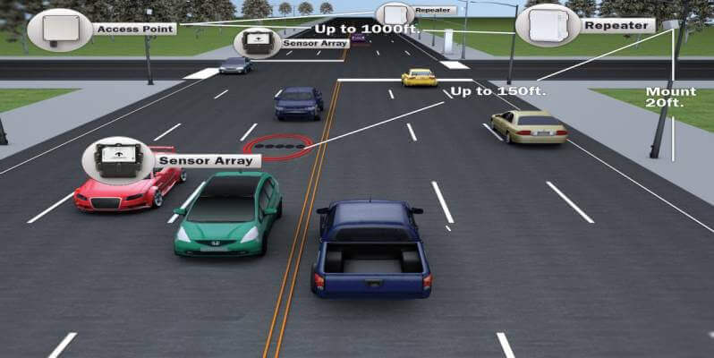

* GPS (Global Positioning System) is commonly utilized in traffic monitoring systems to track and manage the flow of traffic. By using GPS, these systems can gather real-time data on vehicle locations, speeds, and movements, allowing for the efficient monitoring of traffic patterns and the identification of congestion points.
* The GPS receiver measures the time it takes for the signals to travel from the satellites to the receiver.
* By using the difference in time and the known positions of the satellites, the receiver can determine its own distance from each satellite.
* Once the receiver has obtained signals from at least four satellites, it can accurately calculate its three-dimensional position (latitude, longitude, and altitude), as well as its precise time.
* This information can be used for various navigation, mapping, surveying, and timing applications.

PIN CONFIGURATION:

1. *Power Supply:*

- Pin 1: Vcc (Power)

- Pin 2: Ground (GND)

2. *Communication (UART or Serial):*

- Pin 3: TX (Transmit from GPS to the microcontroller)

- Pin 4: RX (Receive into GPS from the microcontroller)

3. *Antenna Connection:*

- Pin 5: Antenna (for GPS signal reception)

4. *Data Output (optional):*

- Pin 6: PPS (Pulse Per Second, optional; used for precise timing applications)

5. *Backup Battery (optional):*

- Pin 7: Backup Battery (some GPS modules have a pin for an optional backup battery to retain data when main power is off)

**\*Microwave Sensors:\***

**DEFINITION:**

* Detects vehicles by emitting microwaves and measuring the reflection.

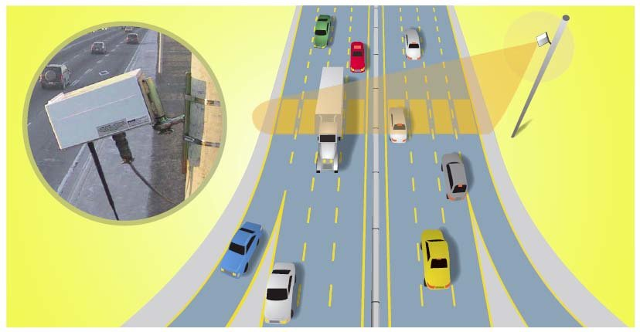

* Microwave sensors are commonly used in traffic monitoring systems for their ability to detect vehicles and measure traffic flow. These sensors work by emitting microwave signals and then analyzing the signals that bounce back after hitting objects, such as vehicles.
* Its primary purpose is to provide real-time or historical data on traffic conditions, including traffic flow, congestion, average speeds, and other relevant parameters, to facilitate efficient transportation management and planning.

PIN CONFIGURATION:

1. *Power Supply:*

- Pin 1: Vcc (Power)

- Pin 2: Ground (GND)

2. *Signal Output:*

- Pin 3: Signal Output (providing information about detected motion)

3. *Control/Input (optional):*

- Pin 4: Control/Input (for configuration or triggering specific functionalities)

4. *Enable/Disable (optional):*

- Pin 5: Enable/Disable (for turning the microwave sensor on or off)

5. *Communication (optional):*

- Pin 6: Communication (TX/RX for data exchange in networked systems)

**\*Acoustic Sensors:\***

* Analyze traffic by detecting sound pattern.

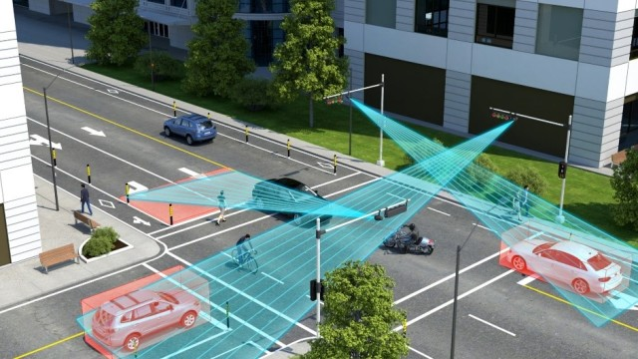

* An acoustic sensor in a traffic monitoring system can detect and analyze sounds associated with traffic, such as vehicle movements, honking, or sirens.
* This technology can contribute to traffic management by providing real-time data on traffic flow, identifying congestion, and even detecting unusual events like accidents.
* They are used in various applications, including:
* Audio recording and surveillance:

Acoustic sensors can capture and record sound for various purposes, such as security, monitoring, or research.

* Vibration analysis:

These sensors can be used to monitor and analyze the vibrations of machinery or structures, helping to identify potential faults, defects, or performance issues.

* Environmental monitoring:

Acoustic sensors can be employed to measure and analyze noise levels in the environment, contributing to efforts to control and reduce noise pollution.

* Seismic activity detection:

Acoustic sensors play a crucial role in detecting and analyzing seismic waves and other ground movements, contributing to earthquake monitoring and early warning systems.

PIN CONFIGURATION:

1. *Power Supply:*

- Pin 1: Vcc (Power)

- Pin 2: Ground (GND)

2. *Signal Output:*

- Pin 3: Signal Output (providing the analog audio signal)

3. *Shield (optional):*

- Pin 4: Shield or Ground (some microphones may have an additional pin for grounding purposes)

**\*Infrared Sensors:\***

**DEFINITION:**

* Measure heat emitted by vehicles to identify their presence.

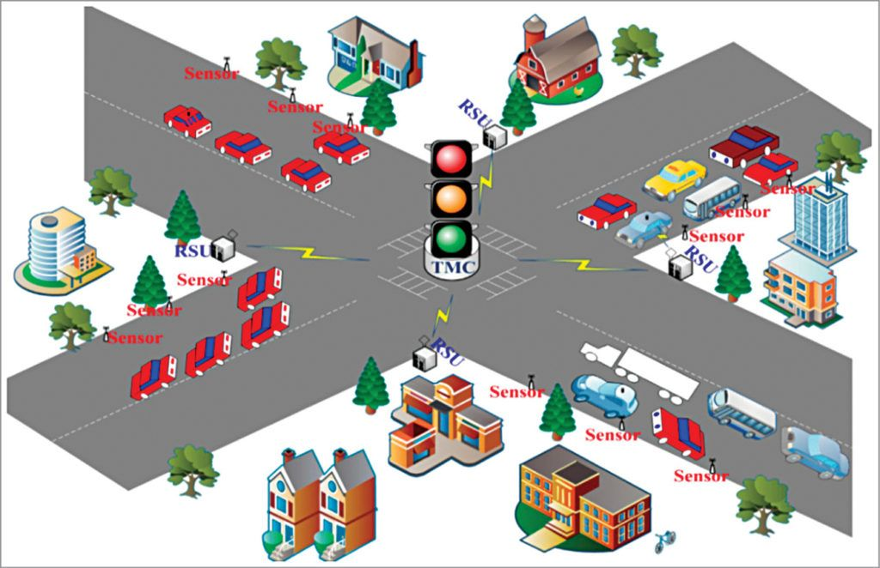

* Infrared sensors play a crucial role in traffic monitoring systems by detecting heat emitted by objects.

PIN CONFIGURATION:

1. *Power Supply:*

- Pin 1: Vcc (Power)

- Pin 2: Ground (GND)

2. *Signal Output:*

- Pin 3: Signal Output (providing information about detected infrared radiation)

3. *Control/Input (optional):*

- Pin 4: Control/Input (for configuration or triggering specific functionalities)

4. *Enable/Disable (optional): - Pin 5: Enable/Disable (for turning the infrared sensor on or off) - Pin 1: Power (Vcc)

- Pin 2: Ground (GND)

- Pin 3: Signal Output (connects to microcontroller)

PROCEDURE:

1. Data Collection:

a. Use Sensors: - Connect and configure your sensors (e.g., cameras, infrared sensors, radar).

- Use libraries or APIs provided by the sensor manufacturers to capture data.

b. Use APIs for Traffic Data: - Explore APIs provided by traffic data providers (e.g., Google Maps API, HERE API) to fetch real-time traffic conditions.

2. Data Processing: a. Preprocess Sensor Data:

- Clean and preprocess raw sensor data.

- Extract relevant features like vehicle count, speed, and congestion level.

b. Integrate External Data:

- Combine sensor data with data from external APIs for a comprehensive view.

c. Implement Machine Learning (Optional):

- Apply machine learning models for predictive analysis or anomaly detection if needed.

3. Traffic Analysis: a. Real-Time Analysis:

- Analyze the data in real-time to identify traffic patterns and congestion.

b. Generate Insights:

- Use statistical methods or machine learning algorithms to generate insights from the data.

4. Visualization:a. Use Plotting Libraries:

- Use Python plotting libraries (e.g., Matplotlib, Seaborn) to create visualizations.

- Plot graphs, charts, or maps to represent traffic flow and congestion

b. Dashboard Development (Optional):

- Develop a web-based dashboard using frameworks like Flask or Django.

- Display real-time traffic information and historical trends.

5. Alerts and Notifications (Optional):a. Set Thresholds:

- Define thresholds for congestion or unusual events.

b. Alert Mechanism:

- Implement an alert system to notify relevant authorities or users when thresholds are exceeded.

6. Deployment:a. Cloud Deployment:

- Host your system on cloud platforms like AWS, Azure, or Google Cloud for scalability.

b. Continuous Monitoring:

- Implement continuous monitoring for system health and data accuracy.

7. Documentation:

a. Code Documentation:

- Document your code for future reference.

**ALGORITHM:**

STEP-1:Building a traffic monitoring system involves various algorithms for data processing, analysis, and visualization.

STEP-2: Below is a simplified example algorithm in Python. This example assumes you have collected data from sensors and want to analyze and visualize traffic patterns.

STEP-3:This is a simple example, and your specific use case might require more advanced algorithms, such as machine learning for predictive analysis or anomaly detection.

STEP-4: Additionally, you may want to integrate data from external sources, implement alert mechanisms, or build a web-based dashboard for visualization.

STEP-5:Feel free to adapt the provided example based on your specific requirements and the structure of your data. If you have more specific needs or questions, please provide additional details for a more tailored solution.

**PROGRAM:**

while True:

# Collect traffic data here

traffic_data = {

"speed": random.randint(0, 100),

"congestion": random.uniform(0, 1),

"latitude": 123.456, # Replace with actual GPS data

"longitude": 789.012, # Replace with actual GPS data

# Add more data as needed

}

headers = {

"Authorization": f"Bearer {api_key}",

"Content-Type": "application/json"

}

response = requests.post(api_endpoint, json=traffic_data, headers=headers)

if response.status_code == 200:

print("Data sent successfully.")

else:

print(f"Failed to send data. Status Code: {response.status_code}")

time.sleep(60) # Adjust the interval as needed

**OUTPUT:**

while True:

# Collect traffic data here

traffic_data = {

"speed": random.randint(0, 100),

"congestion": random.uniform(0, 1),

"latitude": 123.456, # Replace with actual GPS data

"longitude": 789.012, # Replace with actual GPS data

# Add more data as needed

}

headers = {

"Authorization": f"Bearer {api_key}",

"Content-Type": "application/json"

}

response = requests.post(api_endpoint, json=traffic_data, headers=headers)

if response.status_code == 200:

print("Data sent successfully.")

else:

print(f"Failed to send data. Status Code: {response.status_code}")

time.sleep(60) # Adjust the interval as needed